

Individual report
1’500 WORDS

Global banking school

November 2026

Lesjhaun Lee

REPORT TITLE

INTRODUCTION
Crown field eye induction  In this report I’ll be reporting on a simulated healthcare facility that provides specialist treatment that needs to be done for the eye. Currently though, the organization still has old school ways of storing its data using manual documentation. Using applications like Microsoft Word and Excel spreadsheets to store patients details and manage its routine operations. Using these methods can cause problems, including repeated information, conflicting records and delays when searching for patient details. Implementation of a relational database would assist the hospital in maintaining data that is structured, precise and more readily retrievable. The main goal for this project is to construct a relational to administers ophthalmology patients, their appointments, clinicians, if they have any diagnosis, prescriptions, our medications, any follow-up consultations and special treatments. This data will be interconnected with each of these tables to keep organization but also minimize repetition and support the preservation of reliable records. My main role was to develop the Entity Relationship Diagram (ERD), construction SQL tables meanwhile inserting sample data and formulating SQL queries for data retrieval and analysis. This project would show how positive a change to the system will be. |  | DATA IS POWER  
Analysis and design

After doing my own investigation several problems were noticed with the way the hospital information management system stores this vital data. Data was spread across different documents and spreadsheets meaning patient's details were repeated, having inaccurate clinical records leading to problems with keeping information. A basic example of this showed the problem when patients changed their contact numbers changed, one file updates but this means if the old files weren’t leaving finding patients information difficult because it will have all numbers which were inserted into the database. A solution that I came up with for this is to divide the database data into linked tables example: Medication, Treatment, Diagnosis, Patient, Staff and Follow_up .

Entity Relationship Diagram (ERD) this is an easy way to show the relationships between the databases. Making it easier for anyone wanting to access the data can find things easier, like patient table stores there contact details will also have and identification of the patient, staff table store clinical employee information and ophthalmologist. Clinic tables contain specialist clinic details, and appointment records scheduled patient visits. Sometimes a patient can have multiple appointments showing many connections with patient and appointment. Whereas one ophthalmologist can easily manage many appointments. Each appointment is assigned to a staff member, a clinic and a patient. Sometimes patients have multiple diagnosis, meanwhile a diagnosis may apply to multiple patients. This much connection requires an associative table called Patient_diagnosis. Similarly, patient_treatment can connect patients with multiple treatments.

Primary keys uniquely identify records, while foreign keys connect related tables, while foreign keys connect related tables. For example, Patient_ID is the primary key in a patient and foreign key in appointment. These relationships help maintain referential integrity and prevent records from referencing non-existent patients.

Normalization
This is applied to reduce duplication and improve data consistency.

First Normal Formal(1NF): each of the fields hold an atomic value. for example, if there’s multiple diagnosis they shouldn’t be in one patient field. Instead, separate diagnosis is stored in the diagnosis table and linked through patient_diagnosis.

Second Normal Form(2NF): removes partial dependencies by making sure non-key attributes don’t depend on the entire primary key. For example, an associative table using Appointment_ID and Treatment_ID as a composite key should not contain treatment descriptions because these depend only on Treatment_ID. Such information is on the Treatment table.

Third Normal Formal(3NF): Any transitive dependencies were removed, meaning non-key attributes now depend straight on the primary key and nothing else. For example, ophthalmologist contact details are stored in Staff rather than repeatedly recorded in Appointment. The same applies for medication descriptions, which are stored separately in the medication table. By applying 3NF this reduces any data being duplicated and makes the database data reliable once updated. (Connolly and Begg, 2015).

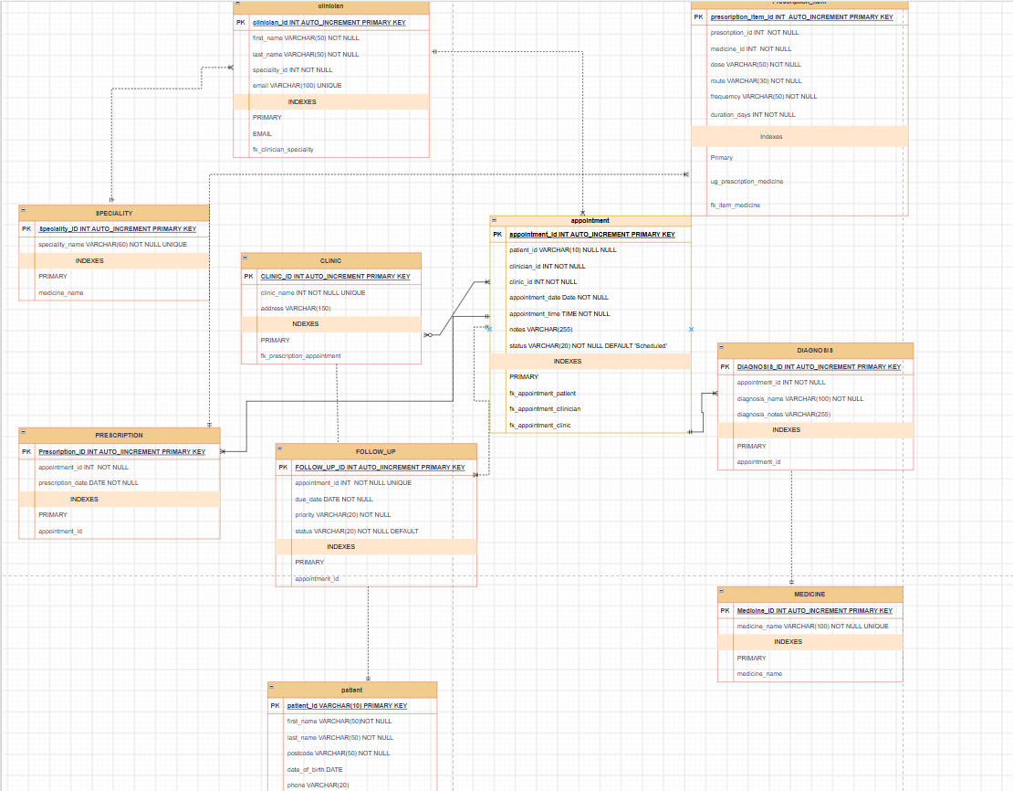
Figure 1 Displays link through tables

Implementation and testing

Implementation and Testing The database was implemented using SQL. The tables and relationships were built using (DDL) commands, and the fictional patient and clinical records were added using DML commands.

The Patient table is illustrated through the following example:

CREATE TABLE PATIENT (

Patient_ID INT PRIMARY KEY,
First_name VARCHAR (50) NOT NULL,
Last_name VARCHAR (50) NOT NULL,
Date_of_birth DATE NOT NULL,
NHS_number VARCHAR (10) UNIQUE,
Phone VARCHAR (20)
);

This statement is used to assign a unique identifier to each patient. NOT NULL ensures essential information is provided, while UNIQUE prevents duplicate NHS numbers.

The Appointment table establishes relationships with patients, staff and clinics:
CREATE TABLE APPOINTMENT (

Appointment_ID INT AUTO_INCREMENT PRIMARY KEY,
Patient_ID VARCHAR (10) NOT NULL,
Staff_ID INT NOT NULL,
Clinic_ID INT NOT NULL,
Appointment_Date DATE NOT NULL,
Appointment_time TIME,
Status VARCHAR (20), NOT NULL DEFAULT

FOREIGN KEY (Patient_ID)
REFERENCES PATIENT (patient_id),

FOREIGN KEY (Staff_ID)
REFERENCES Staff (Staff_ID),

FOREIGN KEY (Clinic_ID)
REFERENCES Clinic (Clinic_ID),

CHECK (Status IN

(‘Scheduled’, ‘Completed’, ‘Canceled’))
) ;

Foreign keys ensure appointments reference existing patients, staff members and clinics. The CHECK constraint makes sure appointment statuses stay within the allowed values. Fictional sample data was inserted to demonstrate how the database stores patient details and clinical information.

Testing

Testing Several testing methods were considered to evaluate functionality. Positive testing involved inserting valid patient, staff and appointment records to confirm successful storage. Constraint testing involved attempting to insert duplicate NHS numbers and invalid foreign key references. These operations should fail because of the UNIQUE and FOREIGN KEY constraints.

Retrieval testing involved executing SELECT statements to confirm stored information could be accessed. Relationship testing used JOIN statements to retrieve information from multiple tables.

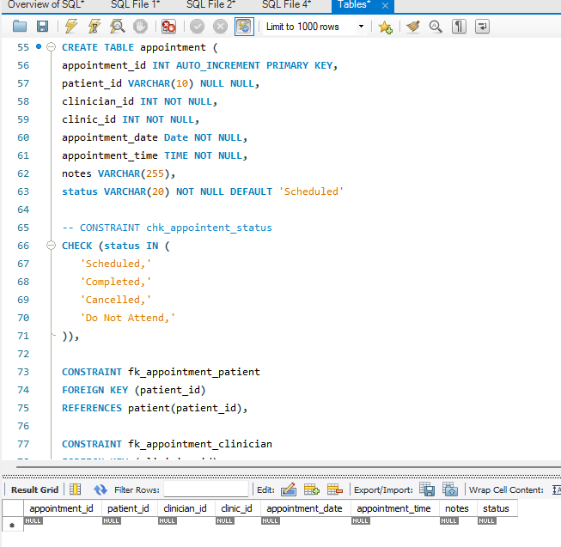

Individual SQL

Individual SQL Six SQL queries were developed to demonstrate how the database supports Crownfield Eye Hospital’s operations.

Query 1: Displaying patient records

SELECT* FROM Patient;

This query is used to display all registered patients record. It demonstrates successful data insertion and allows authorised employees to view patient information.

Query 2: Displaying patient appointments

SELECT *
Patient First_Name,
Patient Last_Name,
Appointment Appointment_Date,
Appointment Status,

FROM Patient
JOIN Appointment
ON Patient Patient_ID = Appointment Patient_ID;

An INNER JOIN combines patient and appointment information. This help administrative staff identify scheduled patient visits and manage bookings.

Query 3: Displaying ophthalmologists and clinics

SELECT*

Staff First_Name,
Staff Last_Name,
Clinic Clinic_Name

FROM Staff

JOIN Appointment
ON Staff Staff_ID = Appointment Staff_ID

JOIN Clinic ON Appointment Clinic_ID = Clinic Clinic_ID;

This query combines three tables to identify which ophthalmologists are assigned to clinics. It supports staff allocation and clinic organisation.

Query 4: Counting appointments by clinic

SELECT*

Clinic_ID,
COUNT (*) AS Total_Appointments

FROM Appointment

GROUP BY Clinic_ID;

COUNT and GROUP BY calculate the number of appointments assigned to each clinic. These results can help management track clinic workloads and understand how many appointments are needed.

Query 5: Displaying upcoming appointments

SELECT*

FROM Appointment
WHERE Appointment_Date >= CURRENT_DATE
AND Status = 'Scheduled'
ORDER BY Appointment_Date ASC;

This query retrieves future scheduled appointments and sorts them chronologically. It helps administrative employees prepare for upcoming patient visits.

Query 6: Displaying patient diagnoses and treatments

SELECT*

Patient First_Name,
Patient Last_Name,
Diagnosis Diagnosis_Name,
Treatment Treatment_Name

FROM Patient

JOIN Patient_Diagnosis

ON Patient Patient_ID = Patient_Diagnosis Patient_ID

JOIN Diagnosis
ON Patient_Diagnosis Diagnosis_ID = Diagnosis Diagnosis_ID

JOIN Patient_Treatment
ON Patient Patient_ID = Patient_Treatment Patient_ID

JOIN Treatment
ON Patient_Treatment Treatment_ID = Treatment Treatment_ID;

This query retrieves patient information alongside associated diagnoses and treatments. Multiple JOIN operations demonstrate how related clinical information can be retrieved from different tables. Access to these results must be restricted to authorised clinical staff.

Security and transactions

Security and Transactions Database security is essential because the system contains confidential patient and clinical information. Access should be restricted according to employee responsibilities. Different roles could be established for administrators, ophthalmologists and clinical staff. For instance, ophthalmologists need access to clinical records, but admin staff might mainly need appointment and contact information. GRANT and REVOKE commands can manage database permissions. Authentication, password protection and encryption should also be implemented.
All systems in the UK must follow General Data Protection Regulation (UK GDPR) and Data protection act 2018 whenever handling personal information. Parametrised queries should be used to reduce SQL injection risks, as they keep user input separate from SQL commands. Transactions provide additional protection when multiple operations must succeed together. COMMIT permanently saves successful changes, while ROLLBACK reverses unsuccessful operations. These methods help maintain database consistency.

Evaluation and reflection

Overall, the proposed database offers Crownfield Eye Hospital a more organized way of managing its ophthalmology records. Instead of relying on separate spreadsheets and documents, the hospital can store information in one connected system. This helps reduce repeated data, keep records more accurate and makes it easier for staff to find the information they need. Using primary keys, foreign keys and validation rules also help ensure that the data is stored correctly and remains consistent. The six SQL queries demonstrate how patient appointments, clinic workloads, staff allocations, diagnoses and treatments can be retrieved to support hospital operations. However, the prototype has limitations. Currently It doesn’t provide real-time clinic availability or integration with existing NHS clinical systems or provide appointment reminders automatically. It also uses fictional sample records rather than live patient information. Soon audit logs, integration with other healthcare systems and enhancing role-based access controls also including automated notifications are improvements that need to be made. On this journey I developed an understanding of SQL implementation, database relationships and testing these, also understanding relational database designs. I also gained experience collaborating to develop a database that addresses organizational requirements.

References

Connolly, T. and Begg, C. (2015) Database Systems: A Practical Approach to Design, Implementation, and Management. 6th edn. Harlow: Pearson.

Information Commissioner’s Office (n.d.) Guide to Data Protection. Available at: https://ico.org.uk/for-organisations/uk-gdpr-guidance-and-resources/ (Accessed: 3 November 2026).

